**Session 2**

**Assignment 2.8**

Student Name: Karthik K

Course: Big Data Hadoop & Spark Training

# Problem Statement

1. Fetch date and temperature from temperature_data where zip HIVE Commands is greater than 300000 and less than 399999.
2. Calculate maximum temperature corresponding to every year from temperature_data table.
3. Calculate maximum temperature from temperature_data table corresponding to those years which have at least 2 entries in the table.
4. Create a view on the top of last query, name it temperature_data_vw.
5. Export contents from temperature_data_vw to a file in local file system, such that each file is '|' delimited.

# Task1

Fetch date and temperature from **temperature_data** where **zip** is greater than 300000 and less than 399999.

### HIVE Commands

***hive (custom) >Select * From temperature_data where zip BETWEEN 300000 AND 399999;***

### Output

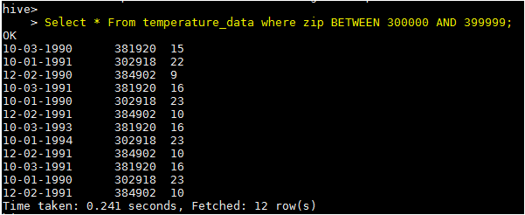

# Task2

Calculate maximum temperature corresponding to every year from **temperature_data** table.

### HIVE Commands

***hive (custom) > SELECT SUBSTRING(full_date,7,4), MAX(temperature) FROM custom.temperature_data GROUP BY SUBSTRING(full_date,7,4);***



### Output

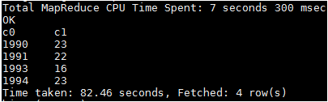

# TASK 3

Calculate maximum temperature from **temperature_data** table corresponding to those years which have at least **2** entries in the table.

### HIVE Commands

***hive(custom)>SELECT full_date, MAX(t1.temperature) as temperature FROM (SELECT SUBSTRING(full_date,7,4) full_date, temperature FROM temperature_data)t1 GROUP BY full_date HAVING count(t1.full_date)>=2;***



### Output

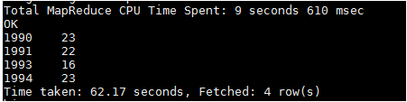

# TASK 4

Create a view on the top of last query, name it **temperature_data_vw.**

### HIVE Commands

***CREATE VIEW temperature_data_vw AS SELECT full_date, MAX(t1.temperature) as temperature FROM (SELECT SUBSTRING(full_date,7,4) full_date, temperature FROM temperature_data)t1 GROUP BY full_date HAVING count(t1.full_date)>=2;***





### Output

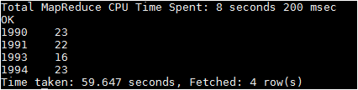

# TASK 5

Export contents from **temperature_data_vw** to a file in local file system, such that each file is '|' delimited.

### HIVE Commands

***INSERT OVERWRITE LOCAL DIRECTORY '/home/acadgild/hadoop/temperature_data_vw.txt' ROW FORMAT DELIMITED FIELDS TERMINATED BY '|' SELECT * FROM temperature_data_vw;***



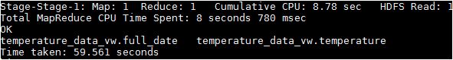

### Output

***cat /home/acadgild/hadoop/temperature_data_vw.txt/\****

